SPANNING TREE
As We Know that, All trees are graphs, but not all graph are trees.
Spanning Tree : A Connected, undirected graph without cycles and it has n vertices, n-1 edges. The Spanning tree of a connected undirected graph G is a Subgraph with all the vertices and “enough” edges to form a tree.
Note: If Graph have loop or parallel edges, remove both.
Properties :
- A Graph may have more than one spanning trees.
- Any two or more spanning trees for a graph have the same no. of edges.
- If a graph is a tree, then its only spanning tree is itself.
Formula :
Total Edges remove from graph for making spanning Tree =Total Edges – Total Vertices + 1
Example:
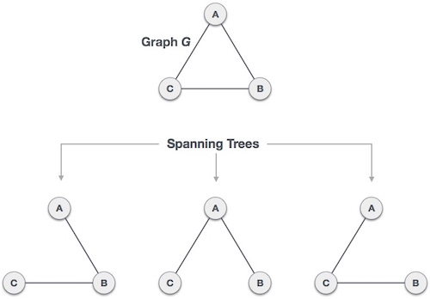
Figure : Spanning Trees with 3 Vertices and 2 Edges. (According to Properties)

Exercise :
Find all the Spanning Trees of the graph given below.
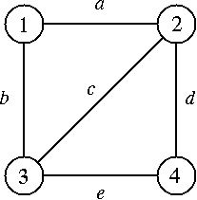
Solution :
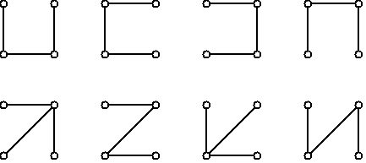

IMP: How many Spaning Trees does a given graph has.
KIRCHOFF’S THEOREM OR MATRIX - THEOREM
Find Matrix (M) : Adjacency Matrix For given Graph.
Change all 1 to -1.
Replacing each diagonal 0 by the degree of corresponding vertex.
Then the no. of spanning trees of Graph is equal to the value of any Co-Factor of M.
Note: If Graph have loop or parallel edges, remove both.

Example : Find the number of Spanning Trees of the Graph G.
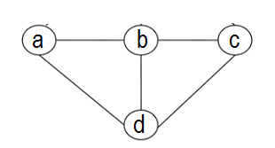
Adjacency Matrix
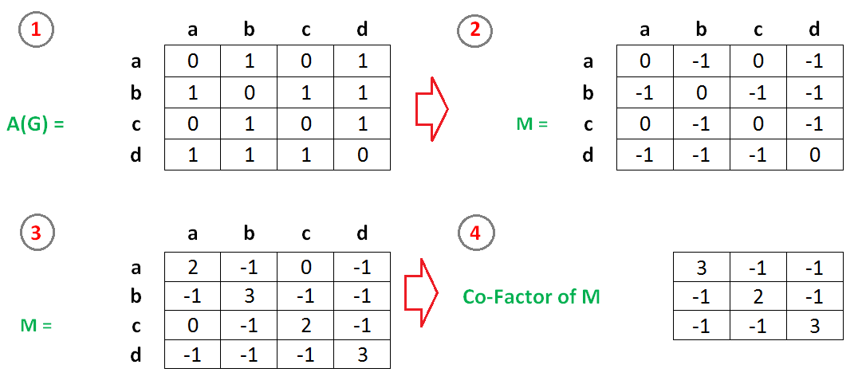

Solve Co-Factor of M
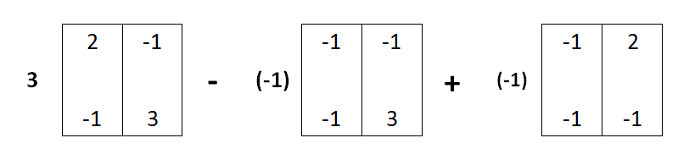
- 3(6-1)+1(-3-1)+(-1)(1+2)
- 3(5)+1(-4)-1(3)
- 15-4-3
- 8
Answer : 8

